Big Spring School District

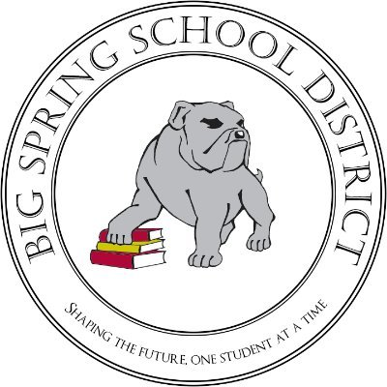

2021 – 2022

COVID-19: Staying Open Plan

(Revised 3/7/22)

# **Table of Contents**

Contents

Table of Contents 2

Thought Exchange Survey Results 4

Health Screening and Safety Protocols 5

Additional Safety Protocols 6

Face Masks: 6

Building 6

Threshold for Universal Masking / 14-Day Window 6

Mount Rock Elementary School 6

Newville Elementary School 6

Oak Flat Elementary School 6

Big Spring Middle School 6

Big Spring High School 6

Home Health Screening: 6

Thermal Scanning: 6

Heating, Ventilation, and Air Conditioning (HVAC) / Disinfectant: 6

Hand Sanitizing Stations: 7

What would happen if there is a confirmed case? 7

**School Symptom Screening Tool for Parents** **8**

Three Tiers of Instruction 9

Tier 1 - Remote Learning 9

Tier 2 - Blended Model 9

Tier 3 - Traditional Face-to-Face 9

Big Spring Cyber Program 10

Selecting an Option for My Student 10

Student Services 11

Contact Information 12

**Message from The Superintendent**

Dear Big Spring School Community:

The summer months give families a great opportunity to step away from the pace of the school year to enjoy time together. I am hopeful that your family has enjoyed this quality time together! Last year, our team developed the structure to this *Staying Open Plan* to provide information regarding key procedures, considerations for the pandemic, and potential modifications to the school structure should the pandemic necessitate adjustments. While progress has been made with the pandemic, the reality is that the pandemic is ever-changing and is clearly not over. As a result, our team has revised our *Staying Open Plan* to proactively prepare for various scenarios that may transpire this school year. Mainstays of the plan include an overview of our instructional delivery model and a summary of health and safety procedures to be employed throughout the District. These plans are intentionally designed to be fluid and adjustments are made in response to developments with the pandemic.

Student and staff safety continue to be our main focus as we deliver our educational program. While there is a collective desire by us all to “return to normal”, doing so safely is our steadfast commitment. Strategically designed, intentional strategies and procedures will enable us to achieve that goal. Our *Staying Open Plan* reflects significant planning by our Pandemic Response Team, key feedback gathered from school and community ThoughtExchange surveys, and information and guidance gathered through collaboration with educational, medical, and health agency partners to the District.

As communicated in an early July communication, our students will return to a Tier 3 learning environment. As defined in this plan, Tier 3 provides for full face-to-face learning, five days per week. Our layered safety strategies and lessons learned over the last year allow for us to return to this structure safely. For families that may not be entirely comfortable with this structure yet, the District is continuing to offer a fully remote, cyber learning program titled Big Spring Cyber. As included later in this document, there will be a process in early August for families to select their desired learning mode for their student in our Back-to-School Gateway. In addition to providing high quality instruction in our face-to-face learning environment, our Big Spring Cyber Program will also be supported by Big Spring Staff.

Over the last year, our school community has demonstrated the importance of partnership. I am confident saying that in the absence of that strong partnership, the success that we collectively realized throughout the pandemic last year would have been impossible. The next several weeks, months, and year will require us to continue to “stand together” as we support each and every learner in the safest manner possible. The dynamic nature of this document will enable us to make on-demand adjustments to meet the evolving nature of the COVID-19 pandemic, while providing the highest quality educational programming for our students!

Ever, Always Strong,

Dr. Kevin C. Roberts, Jr.

Superintendent of Schools

# **ThoughtExchange Survey Results**

Thank you to the over 275 respondents to the recent ThoughtExchange survey that was conducted. We are very fortunate to have such an involved and supportive community. Multiple surveys have been distributed over the past year to both families and staff. Your feedback provided valuable perspectives and helped to inform our decision-making process. Complete results for this ThoughtExchange survey can be accessed by clicking [**here**](https://my.thoughtexchange.com/report/4954a3a841f8b02e8e95f830ed8bad50)**.**

The driving question that was asked was: “What questions or input do you have regarding the 2021-2022 school year?” A snapshot of dominant themes from the top thoughts for participants along with District responses included:

* Continue w/5 days of school a week as planned Students get their education back on track;
  + Response – The 2021-2022 school year will start with five day per week, full face-to-face learning.
* I appreciate all that our district has done to care for all of the students and staff. I am hopeful for a great year and it's very important to my family that the school continues to practice strategies to keep our children that are unvaccinated safe.
  + Response – The District continues to employ layered safety strategies and closely monitors COVID-19 data for any adjustments to safety strategies for all students, staff, and the community.
* Will school sports be supported and allowed this year? Student growth and development in extracurricular activities.
  + Response – Student athletics and activities will be in place this year.
* Will attendance requirements still allow for ease when deciding to keep kids with any COVID-19 symptoms home? Parents who are concerned about strict attendance requirements may be more inclined to send potentially sick children to school.
  + Response – Individuals that are symptomatic will still be encouraged to remain at home. Families will be supported by the school and District to ensure that proactive decisions to protect all students do not negatively impact the family or their student.
* Parent teacher conferences should still be offered virtually and in person. Enables parents to connect with teachers with ease, especially if they cannot take the time off of work. But everyone should have the right to choose.
  + Response – The District benefitted from many experiences last year including the reception of various virtual offerings. The District will provide alternatives like virtual conferences in the coming year.



# **Health Screening and Safety Protocols**

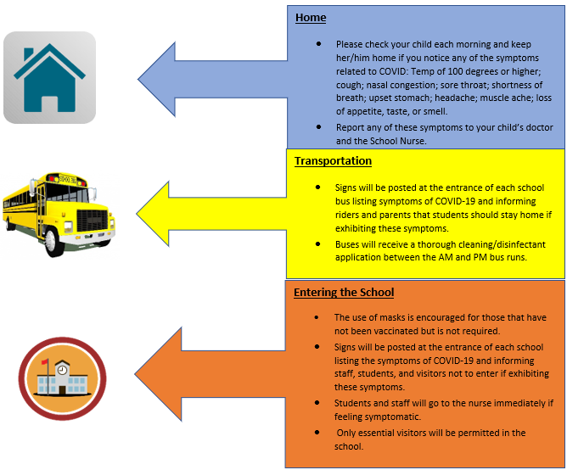

# **Additional Safety Protocols**

The following protocols and procedures have been developed to help safeguard our students and staff. In addition to implementation of key recommendations by the Pennsylvania Department of Health and the Centers for Disease Control and Prevention, these additional safety protocols can serve to keep our schools safe. As more is learned about COVID-19 or additional data comes forward these procedures may be modified to better meet the challenges associated with the pandemic.

## Face Masks:

## The use of masks is encouraged for those that have not been vaccinated but is not required at this time. Face masks will be available for those that choose to wear a mask and do not have one available.

## Home Health Screening:

Prior to coming to school, families should screen their student for any symptoms that could indicate a health concern. CDC’s guidance to support home screening is linked [here.](https://www.cdc.gov/coronavirus/2019-ncov/symptoms-testing/symptoms.html)  This practice, which may serve as a continuation of a routine for many families, can serve to protect all students. Should there be any concern of symptoms that may appear to be indicators of COVID-19, please contact your school nurse or the District’s Head Nurse, Mrs. Dianne Doll at [ddoll@bigspring.k12.pa.us](mailto:ddoll@bigspring.k12.pa.us) or 717-776-2469. Any students that do not feel well should stay home.

## Thermal Scanning:

Thermal scanning will continue to take place at the start of every school day for students and staff. Individuals with a reading at or above 100.4°F will be evaluated by school nurses to determine an appropriate course of action to potentially include isolation and dismissal from school. While only one symptom of COVID-19, thermal scanning to determine the presence of a fever can provide valuable information for student and staff safety.

To support this process, please monitor for any symptoms for your student at home and conduct your own thermal scanning prior to sending them to school. Please keep your student home should any symptoms be present and contact the school to share any pertinent information.

## Heating, Ventilation, and Air Conditioning (HVAC) / Disinfectant:

All HVAC systems throughout all of the District’s buildings have been evaluated to ensure adequate fresh air exchange and to assess overall air filtering. Key thresholds for air exchange, filtering, and levels of humidity have been established and close monitoring and maintenance are ongoing.



With the onset of COVID-19, the District implemented heightened cleaning and disinfecting efforts to provide for a thorough cleaning and disinfecting of high touch surfaces and classroom spaces two times per day. While the disinfectant that is utilized by the school district is of hospital-grade, an additional disinfecting protectant has been secured for another layer of protection. This disinfectant provides 90 days of disinfecting qualities per application, in addition to the daily disinfecting and cleaning efforts outlined above.

## Hand Sanitizing Stations:

Additional hand sanitizing stations have been placed throughout all of the District’s buildings for student and staff utilization. These stations are readily available in common spaces and also in every classroom. These efforts serve as a complement to regular hand washing and hygiene efforts.

# **What would happen if there is a confirmed case?**

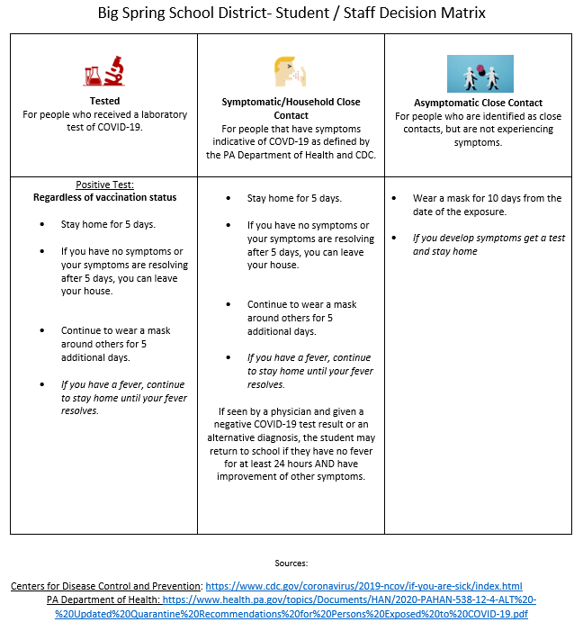There are specific protocols that will be followed if a student or staff member is confirmed to have COVID-19.

|  |
| --- |
| If the District is made aware of a confirmed case, we will follow Pennsylvania Department of Health and [CDC guidelines](https://www.cdc.gov/coronavirus/2019-ncov/if-you-are-sick/quarantine.html) and physician orders regarding safe COVID mitigation and management protocols. Per these guidelines the decision tree below will be utilized for guidance. |

# **School Symptom Screening Tool for Parents**

**Complete Daily Prior to School**

Student Name:

Assigned Class / Group:

Temperature:

Are you / is the student taking any medication to treat or reduce a fever such as ibuprofen (i.e. Advil, Motrin) or Acetaminophen (Tylenol)?

Is student experiencing any of the following?

|  |  |
| --- | --- |
| **GROUP A**  **1 or more symptoms** | **GROUP B**  **2 or more symptoms** |
| Fever (measured or subjective)  Cough  Shortness of breath  Difficulty breathing  New olfactory disorder  New taste disorder | Chills  Rigors  Myalgia  Headache  Sore throat  Nausea or vomiting  Diarrhea  Fatigue  Congestion or runny nose |

**Student should stay home if they**

* Have one or more symptoms in Group A **OR**
* Have two or more symptoms in Group B **OR**
* Are taking fever reducing medication.

Source: [Public Health Guidance for School Communities](https://www.education.pa.gov/Schools/safeschools/emergencyplanning/COVID-19/SchoolReopeningGuidance/ReopeningPreKto12/PublicHealthGuidance/Pages/default.aspx#screening)

# **Three Tiers of Instruction**

While the Big Spring School District will start in Tier 3 (five day, full face-to-face learning), our planning continues to focus on multiple tiers of instruction should adjustments need to be made based on an ever-evolving pandemic. We intend to provide a pathway to transition seamlessly between the tiers as the circumstances require. This means preparing both our students and staff for the knowledge, skills, and resources to successfully move between the tiers. Many lessons were learned throughout the pandemic and we have taken strategic steps to better prepare for the need to pivot into alternative forms of instruction without losing valuable learning time. The table below provides an overview of the three tiers previously presented.

|  |  |
| --- | --- |
|  | Tier 1 - Remote Learning All instruction would shift to online distance learning provided by classroom/course teachers with live and recorded lessons. Specific building and student schedules would be communicated at the time of the decision to move to Tier 1. |
|  | Tier 2 - Blended Model This will enable students to take classes both in person and online. This option reduces the total number of students in the building and enables the school to follow social distancing guidelines. |
|  | Tier 3 - Traditional Face-to-Face This tier provides for full face-to-face instruction, five days per school week, with an option for remote learning through Big Spring Cyber for interested families. |

# **Big Spring Cyber Program**

The District recognizes and understands that, even with safety precautions in place as outlined in our Health and Safety Plan, some families may still not feel comfortable sending their children back to school for face-to-face learning or may have other concerns with the restrictions needed to support student and staff safety. For these families, we have developed a fully online learning opportunity available to all students in grades K-12.

The Big Spring Cyber Program is a full-time cyber option that provides daily instruction in an online environment in conjunction with the Capital Area Online Learning Association ([CAOLA](https://caola.caiu.org/)). This takes the place of existing instruction as the program is administered through partnerships with vendors that provide the content and curriculum resources. This program directly mirrors what students may receive from an outside cyber provider, but the students remain Big Spring students but receive online specific content. In addition, the program is supported by Big Spring staff.

Instruction is aligned to the PA academic standards and is supported by Big Spring School District teachers within specific offerings. To further support students, specific core courses will be facilitated by Big Spring or other staff and require weekly check-ins to review progress, set weekly goals, and receive instructional support as needed.

To learn more about the Big Spring Cyber Program, please visit [www.bigspringsd.org/bssdcyber](http://www.bigspringsd.org/bssdcyber).

You may also contact Mrs. Nicole Donato, Director of Curriculum and Instruction for additional information or with any questions that you may have. To contact Mrs. Donato please email [ndonato@bigspring.k12.pa.us](mailto:ndonato@bigspring.k12.pa.us) or call at 717-776-2000 ext. 2403.

# **Selecting an Option for My Student**

(Face-to-Face or Cyber)

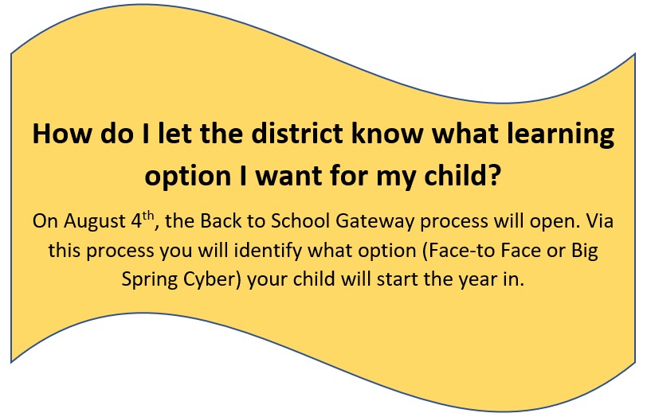

# **Student Services**

Our school counselors, psychologists, nurses, and special education professionals are prepared and available to offer a continuum of supports to meet our student needs. See below for some of the specific services that will be provided.

School Counselors

Our school counselors are an integral part of the students’ daily educational environment. Through their work, our counselors help all students apply academic achievement strategies, manage emotions and apply interpersonal skills, and plan for postsecondary options. Regardless of the learning mode being utilized (Face-to-Face or Big Spring Cyber), our counselors will provide students

* individual academic planning and goal setting,
* short-term counseling,
* referrals for long-term support, and
* support during IEP and 504 meetings.

School Nurses

Each school building will have a nurse present throughout the school day. School nurses will provide daily medications if needed and attend to illness and injuries that might occur during the school day. Mandated health screenings will be completed with social distancing and enhanced cleaning procedures. Immunization requirements remain in effect. School nurses will continue to collaborate with school counselors and administrators to provide for students with special needs, IEPS, 504 Plans and medical needs. School nurses will follow Department of Health and CDC Guidelines related to COVID-19 and will assist administrators and staff in understanding and implementing those guidelines. Each school will have a response plan and a designated isolation area for students or staff that develop signs and symptoms of COVID-19 illness at school.

School Psychologists

District school psychologists will continue to be actively engaged in the evaluation/re-evaluation procedures, collection and review of data, and provide the necessary support needed for those they serve. School psychologists will continue to communicate with the various stakeholders and address specific needs presented to them. This collaboration will allow the district and team of psychologists to provide a continuum of services to our students and families.

Special Education

In an effort to engage students, special education staff will continue to provide instruction, services, and learning opportunities to address the specific needs of the students they serve. Along with engaging students, special education staff will act as a liaison to communicate and collaborate with various stakeholders and coordinate services to maintain compliance with federal and state guidelines. The district is committed to providing a continuum of services to our students. Case managers will be contacting families as soon as we return to school.

# **Contact Information**

We realize there is a great deal of information contained in this document and it could easily become overwhelming. If you have questions, please contact us.

|  |  |  |  |
| --- | --- | --- | --- |
| C:\Users\kroberts\AppData\Local\Microsoft\Windows\INetCache\Content.MSO\629CB718.tmp | C:\Users\kroberts\AppData\Local\Microsoft\Windows\INetCache\Content.MSO\872ADB9D.tmp | Phone Icon PNG Images | Vector and PSD Files | Free Download on ... | Flashlight Icons - Download Free Vector Icons | Noun Project |
| **Location** | **Email** | **Phone** | **Focus Areas** |
| **Dr. Kevin C. Roberts**  *Superintendent*  45 Mount Rock Road  Newville, PA 17241 | [kroberts@bigspring.k12.pa.us](mailto:kroberts@bigspring.k12.pa.us) | 717-776-2000  Ext. 2412 | District Supervision / Direction |
| **Mr. William J. August**  *Assistant Superintendent*  45 Mount Rock Road  Newville, PA 17241 | [baugust@bigspring.k12.pa.us](mailto:baugust@bigspring.k12.pa.us) | 717-776-2000  Ext. 2413 | Building Supervision  Health and Safety Procedures  Building Operations  Transportation |
| **Mrs. Nicole Donato**  *Director of Curriculum and Instruction*  45 Mount Rock Road  Newville, PA 17241 | [ndonato@bigspring.k12.pa.us](mailto:ndonato@bigspring.k12.pa.us) | 717-776-2000  Ext. 2417 | Big Spring Cyber Program Curriculum Development  Professional Learning |
| **Mr. William Gillet**  *Director of Student Services*  45 Mount Rock Road  Newville, PA 17241 | [wgillet@bigspring.k12.pa.us](mailto:wgillet@bigspring.k12.pa.us) | 717-776-2000  Ext. 2422 | Student Services  Special Education Services |
| **Dr. Abigail Leonard**  *Supervisor of Ancillary Services*  45 Mount Rock Road  Newville, PA 17241 | [aleonard@bigspring.k12.pa.us](mailto:aleonard@bigspring.k12.pa.us) | 717-776-2000  Ext. 2401 | Counseling  Nursing / Health Services  Mental Health Services |
| **Mr. Jason Shover**  *Principal – Big Spring HS*  100 Mount Rock Road  Newville, PA 17241 | [jashover@bigspring.k12.pa.us](mailto:jashover@bigspring.k12.pa.us) | 717-776-2000  Ext. 2436 | Principal – Big Spring HS |
| **Mrs. Clarissa Nace**  *Principal, Big Spring MS*  43 Mount Rock Road  Newville, PA 17241 | [cnace@bigspring.k12.pa.us](mailto:cnace@bigspring.k12.pa.us) | 717-776-2000  Ext. 8003 | Principal – Big Spring MS |
| **Mrs. Karen Ward**  *Principal, Mount Rock Elem.*  47 Mount Rock Road  Newville, PA 17241 | [kward@bigspring.k12.pa.us](mailto:kward@bigspring.k12.pa.us) | 717-776-2000  Ext. 3001 | Principal – Mount Rock Elem. |
| **Mr. William Wonders**  *Principal, Newville Elem.*  100 Steelstown Road  Newville, PA 17241 | [wwonders@bigspring.k12.pa.us](mailto:wwonders@bigspring.k12.pa.us) | 717-776-2000  Ext. 4302 | Principal – Newville Elem. |
| **Ms. Stacey Kimble**  *Principal, Oak Flat Elem.*  334 Centerville Road  Newville, PA 17241 | [skimble@bigspring.k12.pa.us](mailto:skimble@bigspring.k12.pa.us) | 717-776-2000  Ext. 5001 | Principal – Oak Flat Elem. |